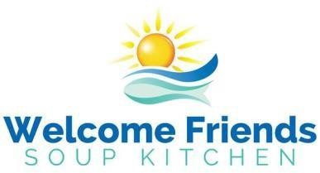
Volunteer Application
volunteerwelcomefriends@gmail.com

Contact Information

Name: ___________________________________________

Street: _________________________________________________________________________________

City: State: Zip Code:

Primary Phone: Email:

Availability & Work Preferences
Days:
Monday Tuesday Wednesday Friday
Times:
Mornings (food prep and cooking) Early afternoon (set up) Evening (serve and clean) Flexible (cleaning, food transportation)

Check the task/responsibility categories you prefer. Not all choices may be available for the day and time slot you require, or the position may be already staffed.

- Chef/Cook
- Prep Food
- Set Up Tables
- Serve Guests
- Clean up Team
- Pack up meals for takeout
- Pick UP/Deliver Food Donations
- Transfer food & supplies
- Deep Clean Crew
Some activities require heavy lifting

- Sort/Store Food Donations
- Other

Additional Information
List skills/experience (e.g., cooking for large groups, foreign language, CPR, Suffolk County Dept. of Health Food Manager Certificate)

How did you learn about volunteering at Welcome Friends?

Have you ever been convicted of a crime? No Yes - If yes, please provide the following information:

Nature of the offense: _____________________________________ Date: _____________________
Disposition of the case

By signing below, I hereby certify that the above statements are true and correct to the best of my knowledge.

Signature Date

PLEASE NOTE - Persons with allergies/sensitivities to certain foods are cautioned that Welcome Friends cannot guarantee that donated and purchased food does not contain ingredients, for example, nuts and gluten, that may cause adverse reactions.

Welcome Friends of Greater Port Jefferson, Inc., DBA Welcome Friends, is a registered 501(c)(3) organization. (rev. January 2026)

